**Space Defenders**

N. Komarov, D. Vladimirtsev

Requirements before running the game

The user must have Python version 3.9 or higher installed on their computer, as well as the Pygame library (version 2.1.2 or higher).

Game rules

The aim of the game is to destroy an army of aliens. Initially, an army appears on a 500x500 pixel window, which consists of 8 rows of 11 aliens in each. There is also a rocket at the bottom of the screen that can shoot at the aliens. Once all the aliens from the first "invasion" are destroyed, a new army appears.

There are 3 types of aliens:

|  |  |  |
| --- | --- | --- |
|  |  |  |
| **1st type** | **2nd type** | **3rd type** |

When each type of alien is destroyed, the player receives 10 points. However, when destroying the 2nd type of alien, the player receives a "Mega Gun" bonus, and when destroying the 3rd type of alien, the player receives an "Extra Life" bonus.

Initially, the player has 1 life in the reserve. If the rocket collides with an alien, the player is considered to have lost the battle and 1 life is taken away, and the alien army is formed anew. However, when receiving the "Extra Life" bonus, the player's life is increased by 1. The maximum number of lives a player can have is 5.

The rocket can fire bullets at the aliens. For one press of the space bar, the rocket emits 1 bullet. However, when receiving the "Mega Gun" bonus, the number of bullets emitted by the rocket at 1 time is increased by 2. The maximum number of bullets that can be fired by a missile is 5 (i.e. either 1, 3, or 5).

Controls

The "A" key is responsible for moving the rocket to the left. If this key is pressed, the rocket can move continuously to the left until the end of the game screen.

The "D" key moves the rocket to the right. If this key is pressed, the rocket may move continuously to the right until the end of the game screen.

The "Space" key is responsible for firing the rocket. One press of this key is one shot.

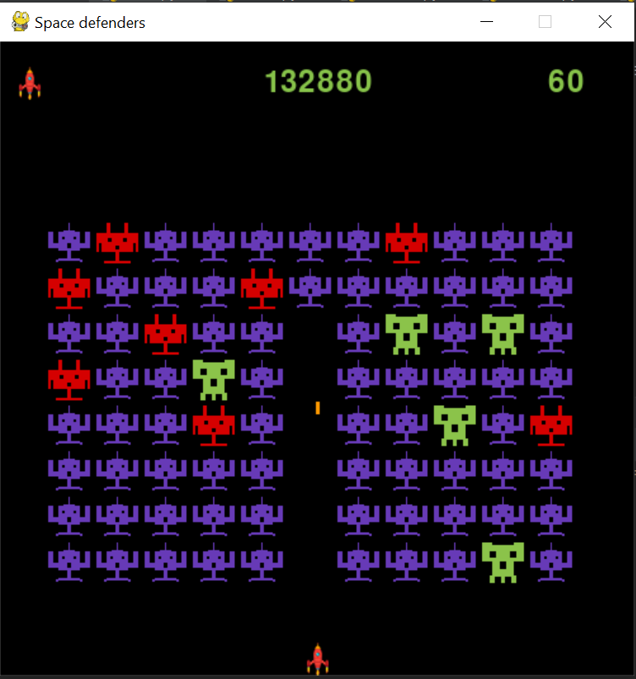 Game interface

The top left corner of the screen displays the number of lives the player currently has. The top center displays the record ever set by the player. The current score is displayed in the top right corner.

End of game

The game is considered to be over if a) the player has quit the game; b) the player has run out of lives. If at the moment of the game end the player's score exceeded his record, it is recorded and displayed as a record on further runs of the game.